Radio Contact

The Spring Game Company is beta testing a new real-time strategy game. In the game, players are soldiers who communicate with each other with virtual radios, and your game limits the range of this virtual radio signal. This reduces the number of other soldiers each player can talk to; each player can only talk to a small group of other players. Because of this, all soldiers get split up into several different squads, and each squad can only relay communications within its own group.

Given the radius of the communication range is 50 units, you must determine how many squads are formed while only knowing X and Y position. In order to be considered part of a squad, a soldier must be standing at or within the communication range of another soldier in that squad. (A message can be relayed from one soldier to another within the squad making it possible for two soldiers to be in the same squad without directly communicating with each other.) The diagram below shows a graphic representation of soldiers (dots) with their communication range (larger circles). There are five squads in the picture below. At the bottom, notice how two communications ranges can overlap without the soldiers being in the same squad if one soldier is not within range of the other. Also notice how networks can be formed by relaying messages from soldier to soldier. Notice that there are 13 soldiers and five different groups. The student tester at the end of this prompt indicates possible location for the scenario below.

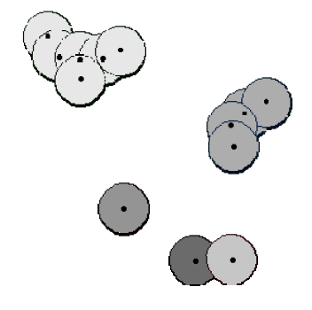
Figure 1

You have been given the completed Location class shown below.

public class Location
{
private int x;
private int y;

public Location (int a, int b) {
x = a;
y = b;
}

public int getX() { return x; }

public int getY() { return y; }

public void setX(int a) { x = a; }

public void getY(int b) { y = b; }

public String toString() {
return "(" + getX() + ", " + getY() + ")";
}

public boolean equals(Object obj) {
Location loc = (Location) obj;
return getX() == loc.getX()
&& getY() == loc.getY();
}
}

Your task is to complete the RadioContact class below. You have been provided a constructor that has an ArrayList<Location> as its sole parameter which contains the location of all soldiers. You are to complete the withinRange and the getNumberSquads methods. The withinRange method returns true if the two location parameters are within 50 units of each other (use the standard distance formula from Euclidean geometry: 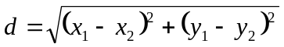. The getNumberSquads method calculates the number of squads as defined in the opening paragraph. The student test is provide following the RadioContact class.

public class RadioContact
{
private ArrayList<Location> al;

public RadioContact() { }

public RadioContact(ArrayList<Location> l) { al = l; }

public int getNumberSquads() { return 5; }

/*
* Range <= 50 units??
*/
public boolean withinRange(Location loc1, Location loc2)
{
if (loc2.equals(new Location(40, 10) ) ) return true;
if (loc2.equals(new Location(60, 10) ) ) return true;
if (loc2.equals(new Location(61, 10) ) ) return false;
return Math.random() <= 0.50;
}
}
The student tester on next page
Radio Contact

public void testRadioContact01()
{
// testing withinRange method
ArrayList<Location> locs = new ArrayList<Location>();
locs.add(new Location(10, 10));
locs.add(new Location(40, 10));
locs.add(new Location(60, 10));
locs.add(new Location(61, 10));
RadioContact rc = new RadioContact(locs);
assertEquals(true, rc.withinRange(locs.get(0), locs.get(1)));
assertEquals(true, rc.withinRange(locs.get(0), locs.get(2)));
assertEquals(false, rc.withinRange(locs.get(0), locs.get(3)));

// getNumberSquads test
// these locations correspond to figure 1.

locs = new ArrayList<Location>();
locs.add(new Location(118, 136));
locs.add(new Location(200, 386));
locs.add(new Location(338, 486));
locs.add(new Location(412, 266));
locs.add(new Location(410, 484));
locs.add(new Location(54, 54));
locs.add(new Location(194, 80));
locs.add(new Location(408, 226));
locs.add(new Location(476, 180));
locs.add(new Location(116, 98));
locs.add(new Location(76, 94));
locs.add(new Location(160, 96));
locs.add(new Location(434, 202));

rc = new RadioContact(locs);
assertEquals(5, rc.getNumberSquads());
}

